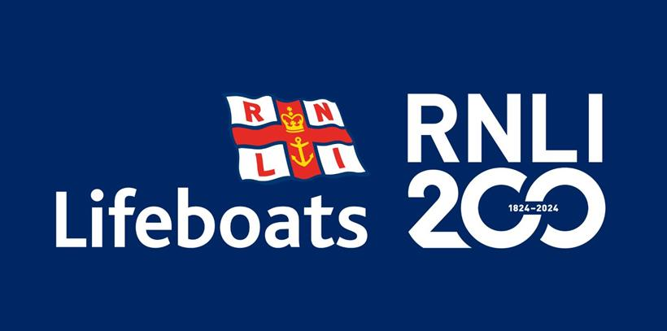
Weymouth Lifeboat Station
Nothe Parade
Weymouth
DT4 8TX

23rd February 2024

Dear Boatowner,

As you may be aware, this year sees the Royal National Lifeboat Institution celebrate its 200th anniversary.

Here in Weymouth, as part of the celebrations, we would like you to join us and our lifeboats in a Boat Parade.

The Parade will take place on Tuesday 14th May. Boats of all shapes and sizes will meet up in Weymouth Bay at 1830, and will then follow our Severn class lifeboat, RNLB Ernest and Mabel, into the harbour.

If you are interested in taking part, please get in touch with our Fundraising Chair, Teresa Drage, before 31st March, with the following details:

- Your name
- The name of your boat
- The length and beam of your boat
- Your contact details – email and mobile phone number

Please pass these details to her at : tdrage69@googlemail.com

We very much hope that you will be able to join us.

Yours faithfully

Tim Abberley

Tim Abberley
Chair, Weymouth Lifeboat Management Group

